Easter Season
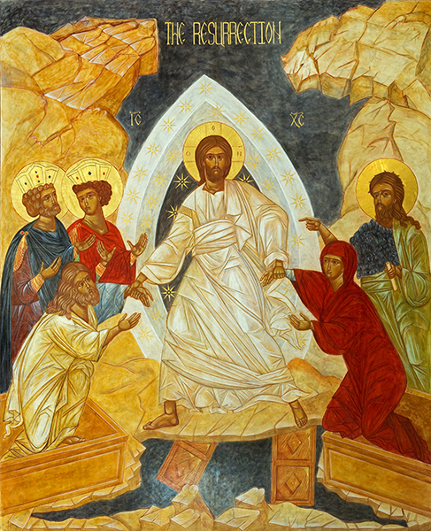

2025

Welcome in the Name of our Lord Jesus Christ

Saint George’s is committed to making a difference in the name of Jesus Christ on the Southside of Savannah and in the greater Church. We accomplish this through exceptional worship, radical hospitality and caring and grace-filled outreach to the community. We are centered in the Sacramental life, the Holy Eucharist being our principal act of worship. We are strengthened by the Body and Blood of Jesus Christ to reach out in welcome to the stranger and in service to the least of our brothers and sisters. We are grounded in the reality of being the Body of Christ in this place, the continuing Incarnation of the reconciling love of Jesus Christ.

The Holy Eucharist: Rite Two

The Word of God
Prelude

Announcements

Hymn see insert

The people standing, the Celebrant says from Easter Day through the Day of Pentecost

Alleluia. Christ is risen.
People The Lord is risen indeed. Alleluia.

The Celebrant may say

Almighty God, to you all hearts are open, all desires known, and from you no secrets are hid: Cleanse the thoughts of our hearts by the inspiration of your Holy Spirit, that we may perfectly love you, and worthily magnify your holy Name; through Christ our Lord. Amen

The Gloria S280

When appointed, the following hymn or some other song of praise is sung or said, all standing

Glory to God in the highest,
and peace to his people on earth.

Lord God, heavenly King,
almighty God and Father,
we worship you, we give you thanks,
we praise you for your glory.

Lord Jesus Christ, only Son of the Father,
Lord God, Lamb of God,
you take away the sin of the world:
have mercy on us;
you are seated at the right hand of the Father:
receive our prayer.

For you alone are the Holy One,
you alone are the Lord,
you alone are the Most High,
Jesus Christ,
with the Holy Spirit,
in the glory of God the Father. Amen.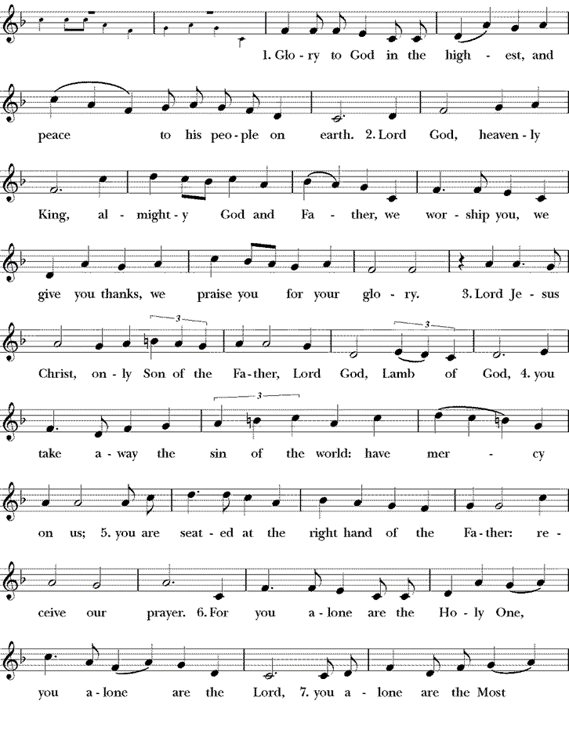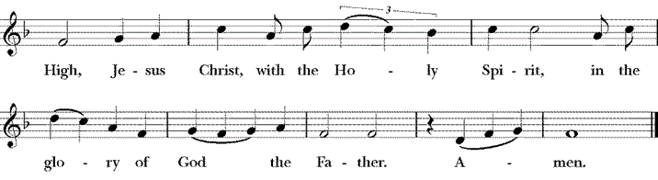
Collect of the Day See Insert

Celebrant The Lord be with you.
People And also with you.
Celebrant Let us pray.

All sit.

First Reading from _____________. See Insert

Reader The Word of the Lord.
People Thanks be to God.

Psalm See Insert

Remain seated.

The Second Reading from ______________. See Insert

Reader The Word of the Lord.
People Thanks be to God.

Gradual Hymn See Insert
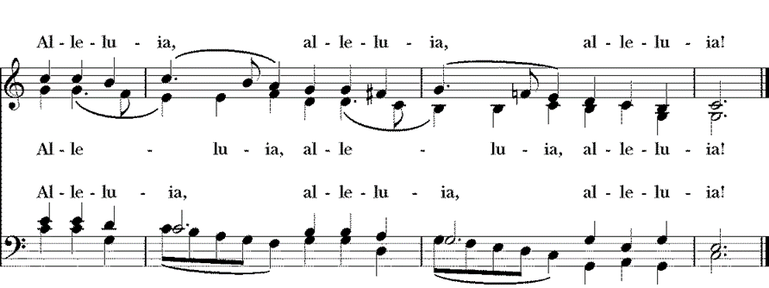
Alleluia
Then, all standing, the Deacon or a Priest reads the Gospel, first saying

The Holy Gospel of our Lord Jesus Christ according to ________ . See Insert
People Glory to you, Lord Christ.

After the Gospel, the Reader says

The Gospel of our Lord.
People Praise to you, Lord Christ.

Alleluia

Sermon

Nicene Creed

All stand.

We believe in one God, the Father, the Almighty, maker of heaven and earth, of all that is, seen and unseen.

We believe in one Lord, Jesus Christ, the only Son of God, eternally begotten of the Father, God from God, Light from Light, true God from true God, begotten, not made, of one Being with the Father. Through him all things were made. For us and for our salvation he came down from heaven: by the power of the Holy Spirit he became incarnate from the Virgin Mary, and was made man. For our sake he was crucified under Pontius Pilate; he suffered death and was buried. On the third day he rose again in accordance with the Scriptures; he ascended into heaven and is seated at the right hand of the Father. He will come again in glory to judge the living and the dead, and his kingdom will have no end.

We believe in the Holy Spirit, the Lord, the giver of life, who proceeds from the Father [and the Son.] With the Father and the Son he is worshiped and glorified. He has spoken through the Prophets. We believe in one holy catholic and apostolic Church. We acknowledge one baptism for the forgiveness of sins. We look for the resurrection of the dead , and the life of the world to come. Amen.

Peace

All stand. The Celebrant says to the people

Celebrant The peace of the Lord be always with you.
People And also with you.

Then the Ministers and the People may greet one another in the name of the Lord.

Announcements

The Celebrant says the following or some other suitable Offertory Sentence

Ascribe to the Lord the honor due his Name; bring offering and come into his courts. Psalm 96:8

Offertory See Insert

The Doxology

Praise God, from whom all blessings flow;
Praise Him, all creatures here below;
Praise Him above, ye heavenly host;
Praise Father, Son, and Holy Ghost. Amen.

The Holy Communion

The Great Thanksgiving
The people remain standing.
The Celebrant announces the intention for the Mass

Celebrant The Lord be with you.
People And also with you.
Celebrant Lift up your hearts.
People We lift them to the Lord.
Celebrant Let us give thanks to the Lord our God.
People It is right to give him thanks and praise.

Then, facing the Holy Table, the Celebrant proceeds

It is truly right to glorify you, Father, and to give you thanks; for you alone are God, living and true, dwelling in light inaccessible from before time and for ever.

Fountain of life and source of all goodness, you made all things and fill them with your blessing; you created them to rejoice in the splendor of your radiance.

Countless throngs of angels stand before you to serve you night and day; and, beholding the glory of your presence, they offer you unceasing praise. Joining with them, and giving voice to every creature under heaven, we acclaim you, and glorify your Name, as we say,

Santus S124

Celebrant and People

Holy, Holy, Holy Lord, God of power and might,
heaven and earth are full of your glory.
Hosanna in the highest.
Blessed is he who comes in the name of the Lord.
Hosanna in the highest.

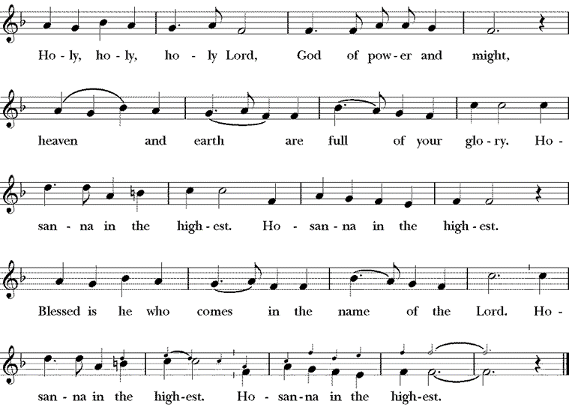
The people stand or kneel.

Then the Celebrant continues

We acclaim you, holy Lord, glorious in power. Your mighty works reveal your wisdom and love. You formed us in your own image, giving the whole world into our care, so that, in obedience to you, our Creator, we might rule and serve all your creatures. When our disobedience took us far from you, you did not abandon us to the power of death. In your mercy you came to our help, so that in seeking you we might find you. Again and again you called us into covenant with you, and through the prophets you taught us to hope for salvation.

Father, you loved the world so much that in the fullness of time you sent your only Son to be our Savior. Incarnate by the Holy Spirit, born of the Virgin Mary, he lived as one of us, yet without sin. To the poor he proclaimed the good news of salvation; to prisoners, freedom; to the sorrowful, joy. To fulfill your purpose he gave himself up to death; and, rising from the grave, destroyed death, and made the whole creation new.

And, that we might live no longer for ourselves, but for him who died and rose for us, he sent the Holy Spirit, his own first gift for those who believe, to complete his work in the world, and to bring to fulfillment the sanctification of all.
When the hour had come for him to be glorified by you, his heavenly Father, having loved his own who were in the world, he loved them to the end; at supper with them he took bread, and when he had given thanks to you, he broke it, and gave it to his disciples, and said, "Take, eat: This is my Body, which is given for you. Do this for the remembrance of me."

After supper he took the cup of wine; and when he had given thanks, he gave it to them, and said, "Drink this, all of you: This is my Blood of the new Covenant, which is shed for you and for many for the forgiveness of sins. Whenever you drink it, do this for the remembrance of me."

Father, we now celebrate this memorial of our redemption. Recalling Christ's death and his descent among the dead, proclaiming his resurrection and ascension to your right hand, awaiting his coming in glory; and offering to you, from the gifts you have given us, this bread and this cup, we praise you and we bless you.

Celebrant and People

We praise you, we bless you,
we give thanks to you,
and we pray to you, Lord our God.

The Celebrant continues

Lord, we pray that in your goodness and mercy your Holy Spirit may descend upon us, and upon these gifts, sanctifying them and showing them to be holy gifts for your holy people, the bread of life and the cup of salvation, the Body and Blood of your Son Jesus Christ.

Grant that all who share this bread and cup may become one body and one spirit, a living sacrifice in Christ, to the praise of your Name.

Remember, Lord, your one holy catholic and apostolic Church, redeemed by the blood of your Christ. Reveal its unity, guard its faith, and preserve it in peace.

[Remember (NN. and) all who minister in your Church.]
[Remember all your people, and those who seek your truth.]
[Remember .]
[Remember all who have died in the peace of Christ, and those whose faith is known to you alone; bring them into the place of eternal joy and light.]

And grant that we may find our inheritance with [the Blessed Virgin Mary, with patriarchs, prophets, apostles, and martyrs, with St. George, our patron and] all the saints who have found favor with you in ages past. We praise you in union with them and give you glory through your Son Jesus Christ our Lord.

Through Christ, and with Christ, and in Christ, all honor and glory are yours, Almighty God and Father, in the unity of the Holy Spirit, for ever and ever. AMEN.

The Celebrant then continues

And now, as our Savior Christ has taught us, we are bold to say,

People and Celebrant

Our Father, who art in heaven,
hallowed be thy Name,
thy kingdom come,
thy will be done,
on earth as it is in heaven.
Give us this day our daily bread.
And forgive us our trespasses,
as we forgive those
who trespass against us.
And lead us not into temptation,
but deliver us from evil.
For thine is the kingdom,
and the power, and the glory,
for ever and ever. Amen.

Breaking of the Bread

A period of silence is kept.

Celebrant Alleluia. Christ our Passover is sacrificed for us;
People Therefore let us keep the feast. Alleluia.

Fraction Anthem Jesus, Lamb of God S164

Jesus, Lamb of God, Have mercy on us.
Jesus, bearer of our sins, have mercy on us.
Jesus, redeemer of the world: give us your peace.
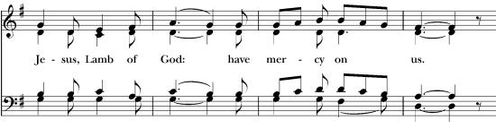
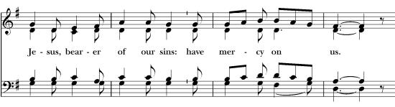

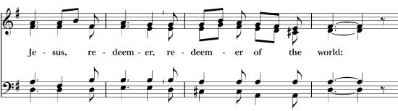

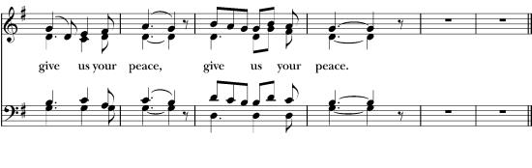

The Celebrant says

This is the Lamb of God, who takes away the sins of the World, Happy are they who are called to his supper.
Lord, I am not worthy to receive you, but only say the word and my soul shall be healed.

Spiritual Communion

In union, dear Lord, with the faithful at every altar of your Church where your blessed Body and Blood are being offered to the Father, I desire to offer you praise and thanksgiving. I believe that you are truly present in the Holy Sacrament. And since I cannot now receive you sacramentally, I beseech you to come spiritually into my heart. I unite myself to you, and embrace you with all the affections of my soul. Let me never be separated from you. Let me live and die in your love. Amen.

Come Lord Jesus, dwell in your servant in the fullness of your strength, in the perfection of your ways, and in the holiness of your spirit, and rule over every hostile power in the might of your spirit, and to the glory of your Father. Amen

May the Body and Blood of our Lord Jesus Christ preserve my body and soul unto everlasting life. Amen.

After Communion, the Celebrant says

Let us pray.

Celebrant and People

Almighty and everliving God, we thank you for feeding us with the spiritual food
of the most precious Body and Blood of your Son our Savior Jesus Christ; and for assuring us in these holy mysteries that we are living members of the Body of your Son, and heirs of your eternal kingdom. And now, Father, send us out to do the work you have given us to do, to love and serve you as faithful witnesses of Christ our Lord. To him, to you, and to the Holy Spirit, be honor and glory, now and for ever. Amen.

Benediction

The priest blesses the people, saying

The God of peace, who brought again from the dead our Lord Jesus Christ, the great Shepherd of the sheep, through the blood of the everlasting covenant, make you perfect in every good work to do his will, working in you that which is well-pleasing in his sight; and the blessing of  God Almighty, the Father, the Son, and the Holy Spirit, be among you, and remain with you always. Amen.

Hymn See Insert

Dismissal

Priest Let us go forth in the name of Christ. Alleluia, Alleluia.
People Thanks be to God. Alleluia, Alleluia.

